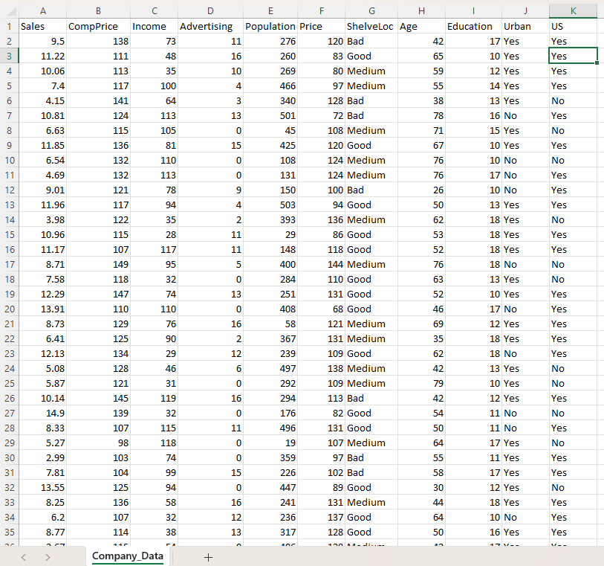

Name of Feature Description Type Relevance w.r.t other Features
1.Sales Sailing product department Quantitative, Continuous Relevant, Units sold per product from company data
2.Comp_price Competitor Price Quantitative, Discrete Marginally Relevant, price charged
by the competitor vendor at the same time
3. Income Area Income Quantitative, Discrete Relevant, Middle household
income value from lowest to highest in an area
4.Advertising promotion Quantitative, Discrete Relevant, Local publicity budget spent by the company
5.population Company Quantitative, Discrete Relevant, Local population size in
population company area
6.price Company Price Quantitative, Discrete Relevant, Company’s own price per
product
7.ShelveLoc Shelf quality per location Qualitative, Categorical Low Relevance, Quality of shelf
display location
8.Age Average Age Quantitative, Discrete Relevant, Average age of local
Population
9.Education Education Level Quantitative, Discrete Relevant, Company’s growth
depends upon the Education level
10.Urban Urban Area Qualitative, Categorical Low relevance, whether the
company store is in urban area or
not (Yes/No)
11.US United States Qualitative, Categorical Low relevance, whether the
company store is in US area or
not (Yes/No)

